117A1063

EXPERIMENT NO:-5

AIM:-To perform Multi-Factor Authentication (MFA) using aws.

PROCEDURE:-

1)Created a root user and signed in Successfully and Download Google Authenticator Extension.

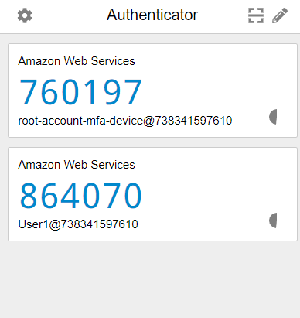

2)Navigate to the IAM Dashboard.

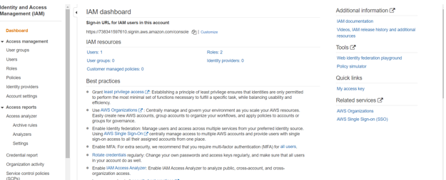

3)Created a User named (User1).

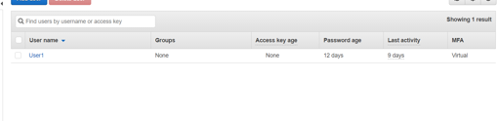

4)Did the Security Credential setting.

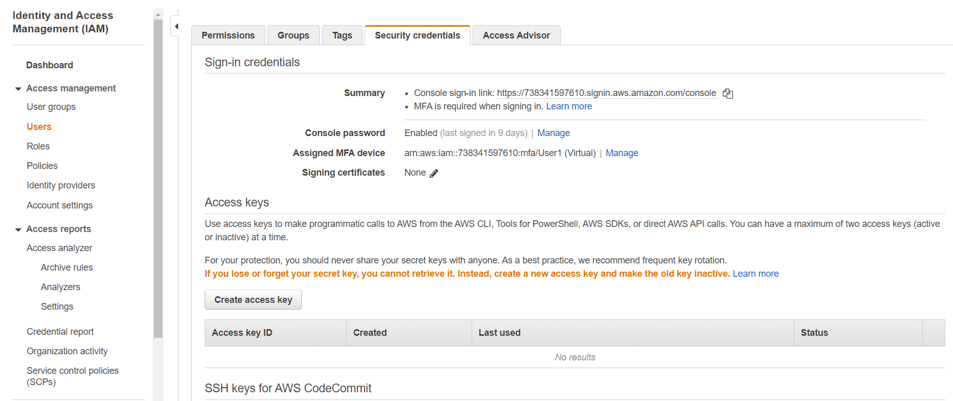

6)Logged In successfully into IAM user.

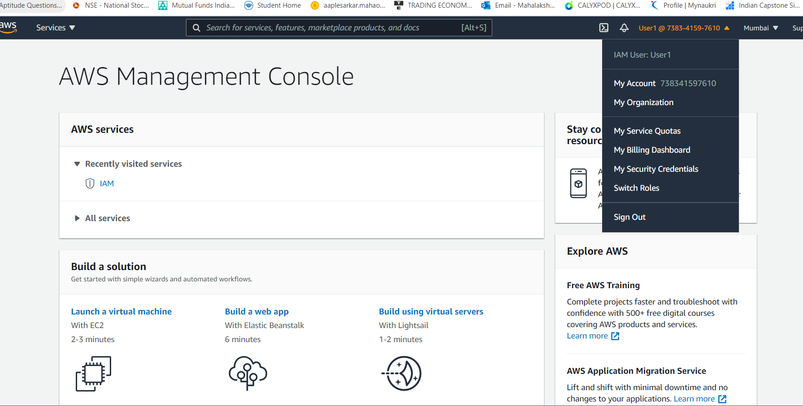

CONCLUSION:-The Multi Factor Authentication of the user account has successfully been done.